**Auto Scaling practice**

Step 1. Launch instance with t2.micro in default VPC.

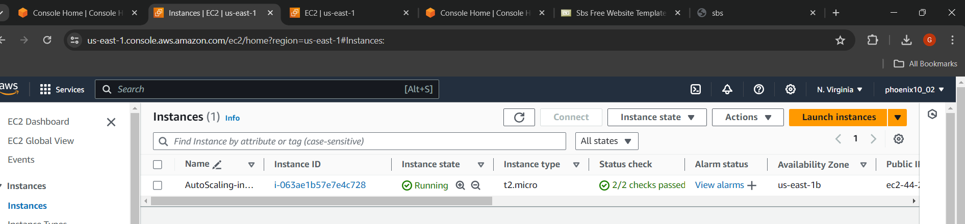

Step -2 Install httpd server

#yum install httpd -y

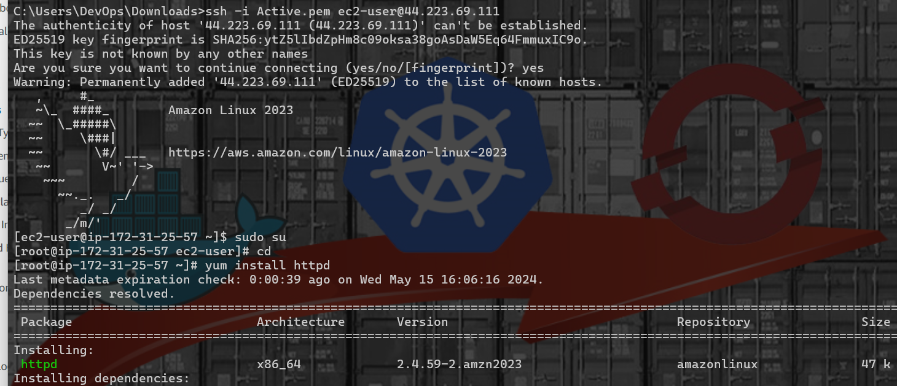

Step 3- Move to /var/www/html directory by

#cd /var/www/html

Wget the website link #wget <https://www.free-css.com/assets/files/free-css-templates/download/page295/sbs.zip>

And unzip the zip file.

#unzip sbs.zip

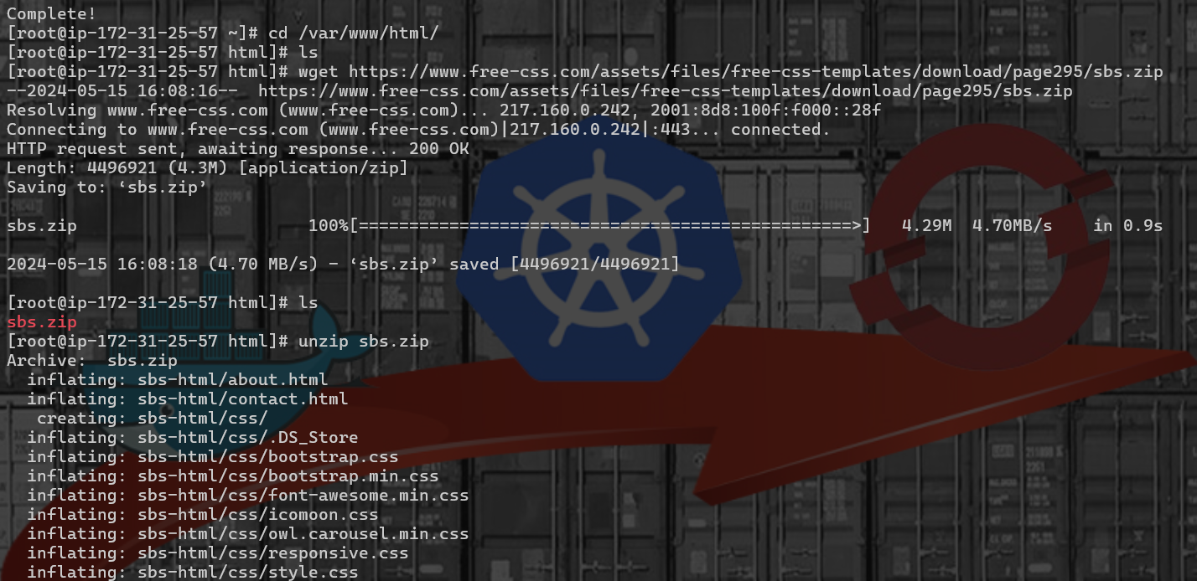

Step 4: After unzip copy the all file of sbs-html inside /var/www/html directory

#cp -rvf sbs—html/* .

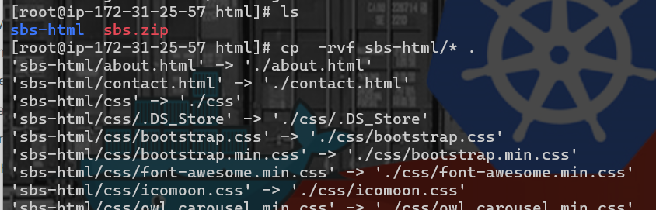

Step 5: Start and enable the httpd service

#systemctl start httpd.service

#systemctl enable httpd.service



Step 6: Browse with instance public ipv4 on browser 44.223.69.111

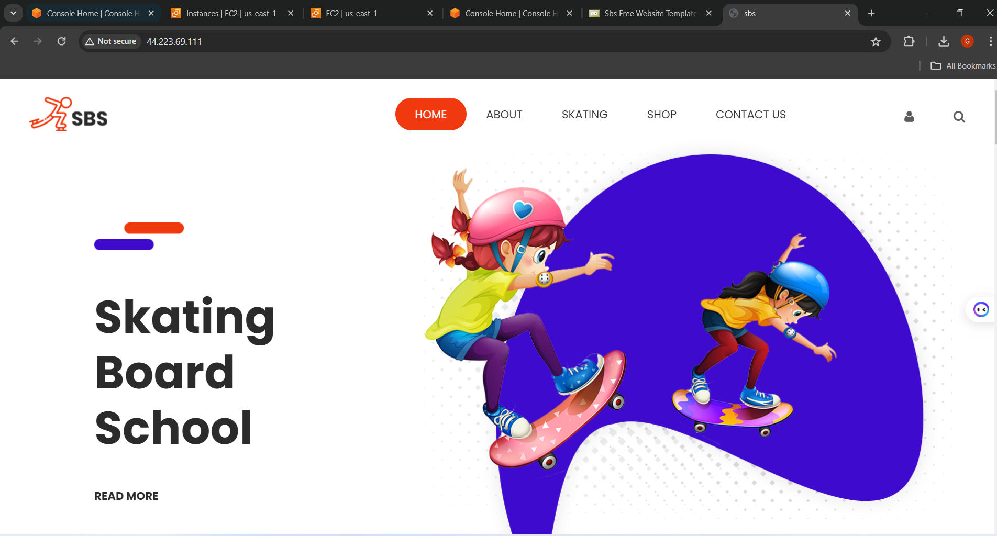

Step 7. Create image template by clicking on Action > Image and Template > Create image

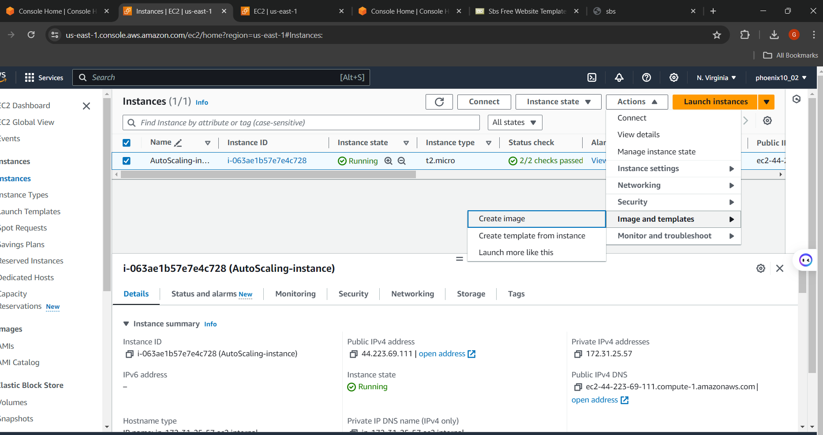

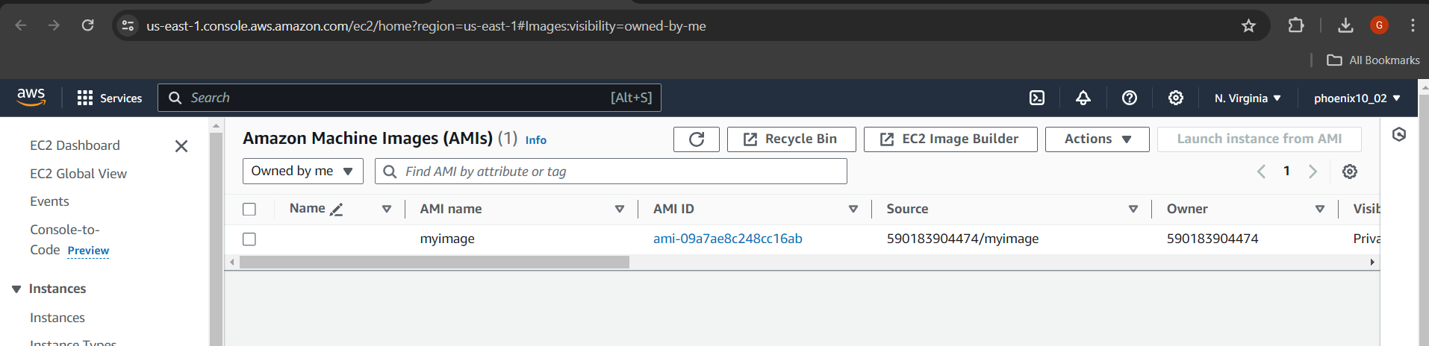

Step 8: Go top Amazon EC2 Auto Scaling

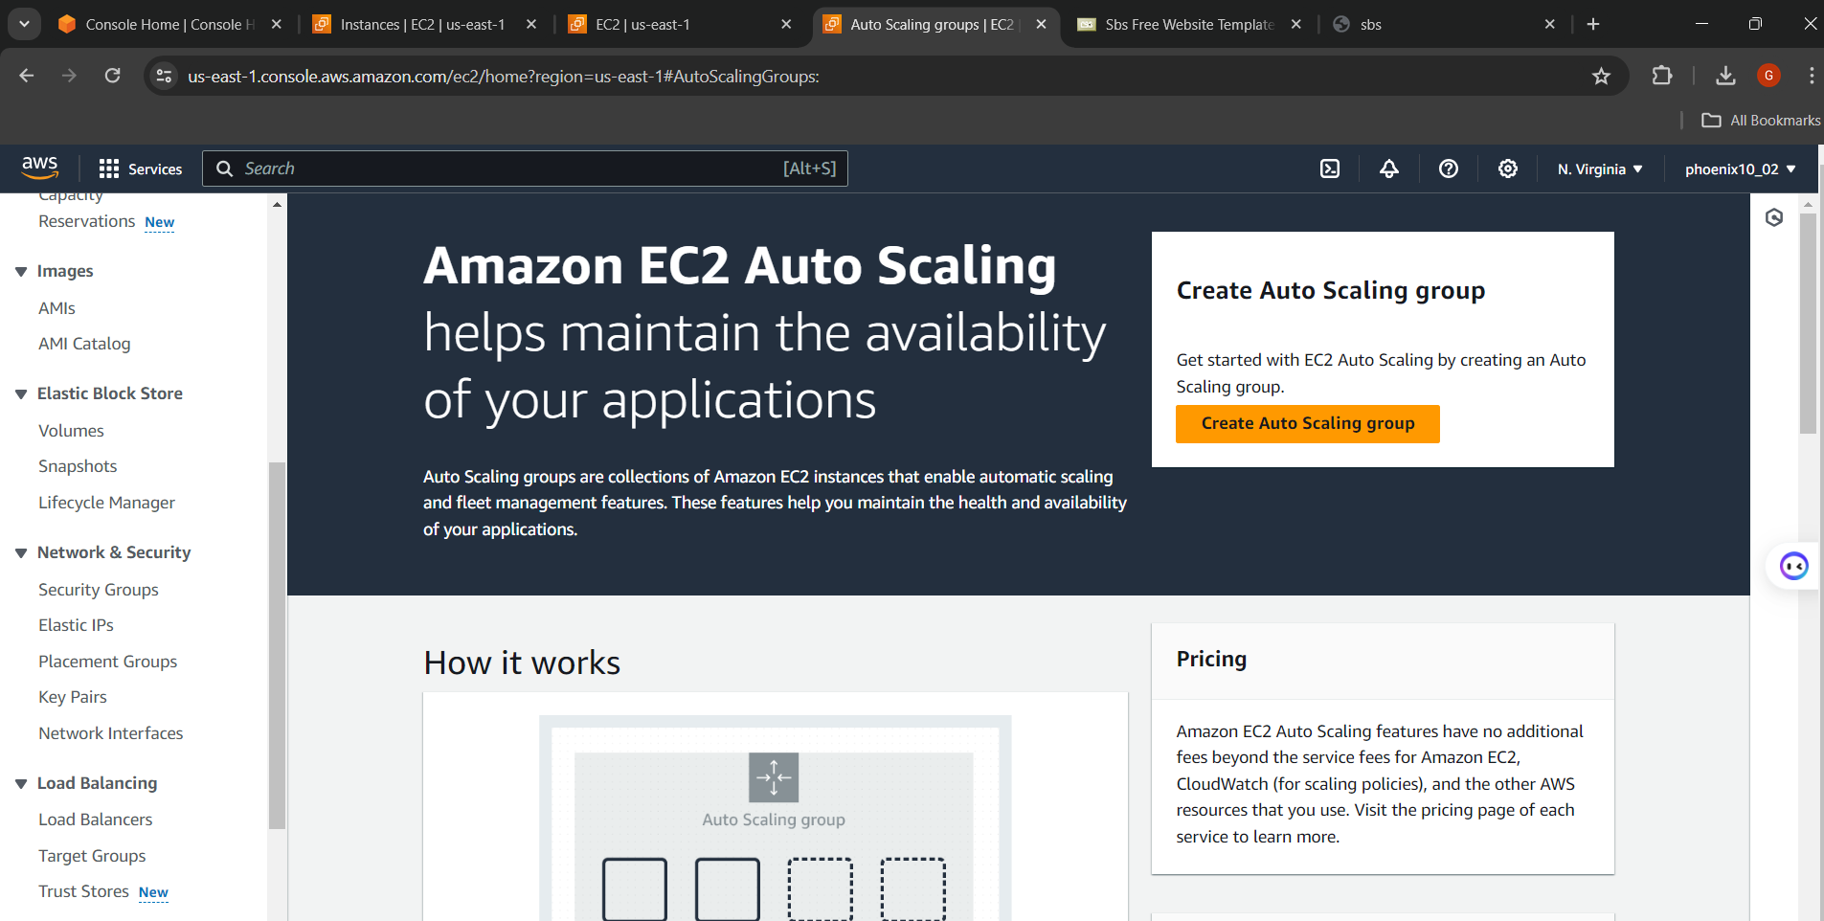

Step 9. Assign name of Auto Scaling group name :myauto-sg

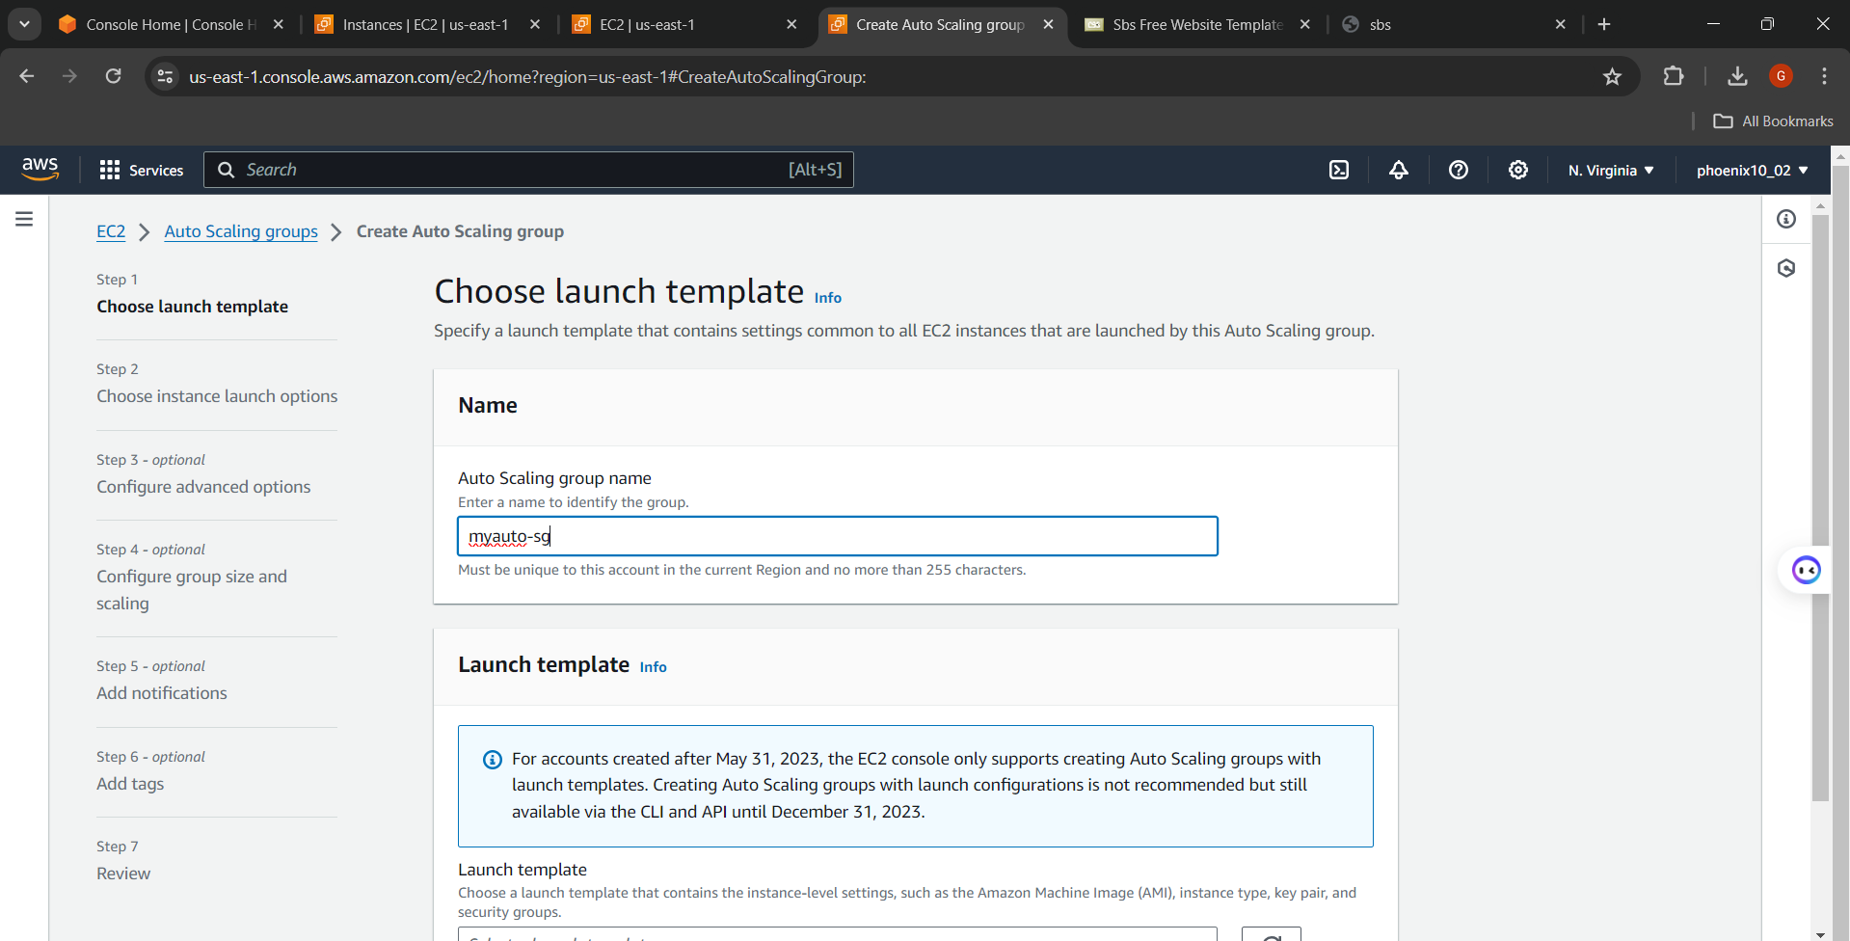

Step 10 . Launch template and assign name

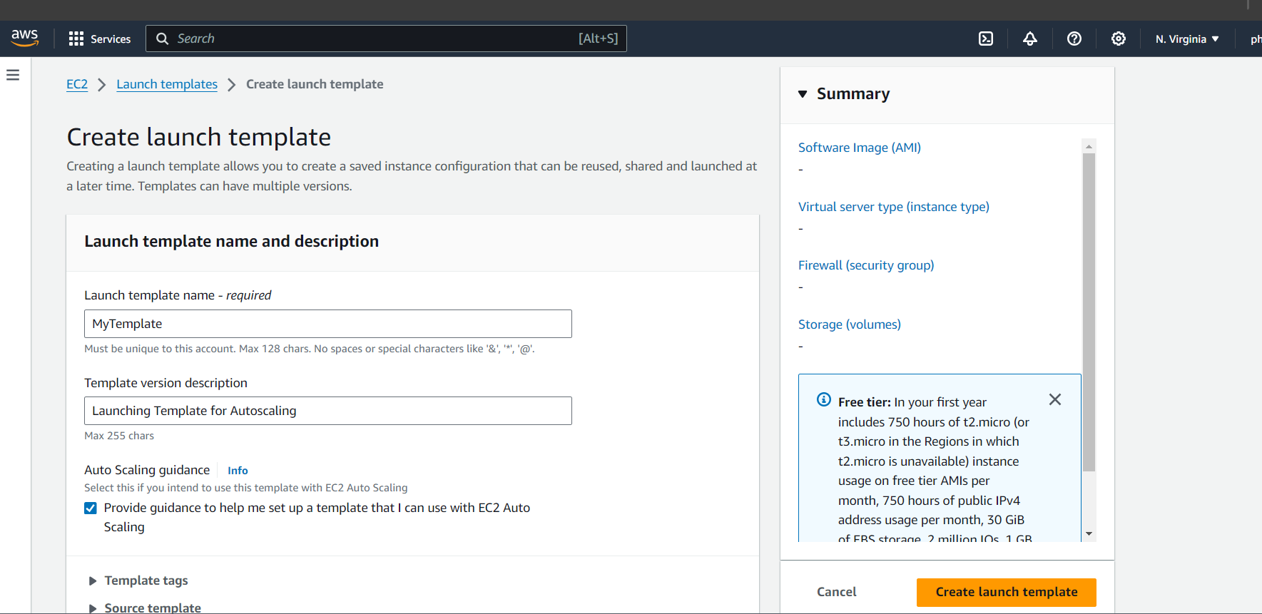

Step 11. Choose IAM image from which we create .

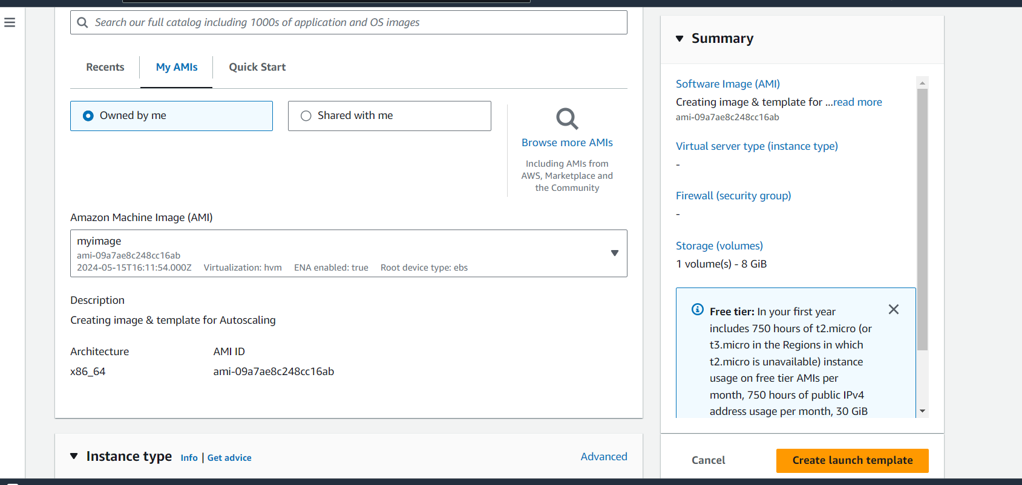

Configure instance type key pair

